South American Constructivism and Concrete Art

Nonfigurative painting based on structural and geometric principles can be traced back in South America to 1923 in the works of the Argentinean painter and theoretician Emilio Pettoruti (1892-1971) and the 1925 paintings of the Italian born Argentinean artist Juan del Prete (1897-1978). However, the earliest attempt to found a constructivist school in South America is the creation of the Asociacion de Arte Constructivo (AAC) in 1935 by the Uruguayan painter and ideologist Joaquin Torres Garcia (1874-1949), followed by the foundation of various concrete art associations in Argentina and Brazil and the blossom of constructivist sculpture ad painting specially in Colombia in the fifties.

Constructive Universalism
Universalismo Constructivo (Constructive Universalism), the underlying doctrine of the Montevideo based AAC from 1935 to 1940 and El Taller Torres Garcia (TTG) opened in 1943 and closed in 1967, was a result of the development of Joaquin Torres Garcia’s plastic and humanistic theories from a Mediterranean classical style towards a personal interpretation of geometric abstraction; close to that of the Dutch Neoplasticists Theo Van Doesburg and Piet Mondrian, strongly influenced by western-European medieval architecture and Mesoamerican Pre-Columbian arts, crafts, architecture and philosophy. These two tendencies were mediated by what he considered universal metaphysical plastic and spiritual elements as the golden section, the orthogonal grid, and a series of schematized universal symbols of reason, emotion and mater. By the time Torres Garcia co-founded the Cercle et carre group along with the French artist Michael Seuphor in Paris in 1930 the difficulties to insert his humanistic views and symbols in the order of geometric abstraction were evident. Jean Hélion, who befriended Torres Garcia and who, as many other geometric abstract artists, was worried by the fast spreading of surrealism and it’s praised of irrationality, hardly criticized Torres’s eclecticism considering it at once anti-mathematic and antihuman. This dialogue between pure geometric abstraction and humanistic values was present in most manifestations of concrete and constructivist art in the South American subcontinent; in any case after the dissolution of the TTG, attention to the material qualities of the object and a renounce to the use of humanistic symbols was evident.

The AAC and TTG
After a 43 years period outside his country Torres Garcia returned to Uruguay in 1934 announcing the creation of a Soceidedad de artes del Urugay under the premise of erasing the limits between artists and artisans. His ambitious project resulted on the foundation of the AAC on 1935 which, particularly from 1937 on, produced planar geometric painting dominated by earthly and primary colors, based on a structural orthogonal grid in which schematic symbols as the sun, the fish, or the human figure were inserted. Besides the collective production of ceramics, textiles and stained glass some of the members of the AAC and TTG experimented with wood constructions, as Francisco Mato, Gonzalo Fonseca and Julio Alpuy; created wooden toys, as Elsa Andrade and Horacio Torres; specialized on large stone engraving and sculpture, as Horacio Torres, Gonzalo Fonseca and Francisco Mato; or went into metallurgic as Olga Piria, Horacio Torres and Augusto Torres. Monumento Cosmico (1937) and the Mural paintings at the Hospital Saint Bois (1944) were the most important collective works of the group. The first, a carefully engraved pink granite wall situated in the Park Rodo, synthetizes the plastic and humanistic premises of Universalismo Constructivo through the hierarchical disposition of emotional and rational symbols engraved on the surface; while the colorful murals on the Martirine Wing of the Hospital Saint Bois mark a stage of harsh criticism against the work of the TTG. This is a period full of contradictions in which Torres Garcia wished no longer to promote his doctrine, not only as a result of the attacks of art critics as José Cuneo, Herrera Maclean or Eduardo Vernazza against his work, but mainly for what he called the conspiracy of silence against his pedagogical enterprise. More than 500 conferences on constructive art, pre-Columbian thought, and modern European painting given in Montevideo had little impact on the Uruguayan society. By 1943 the AAC was no longer active and the TTG was the responsible for the production of constructivist art even after the death of Torres Garcia in 1949.

From Constructivism to Concrete art
Benefiting from the path opened by Torres Garcia to geometrical and concrete abstraction, but in odds with his Universalismo Constructivo, The Asociación de Arte Concreto Invención (AACI) was created in 1945 by the Argentinean painter and graphic designer Tomas Maldonado who worked as director of the Hochschule für Gestaltung in Ulm between 1954 and 1966. He and Camilo Arden Quin, who along with the Hungarian born painter Guyla Kosice co-founded the constructivist related MADI association in 1946, met Joaquin Torres Garcia in 1942 and contributed with him to the only issue of the Arturo Magazine (1944), a publication dedicated to abstract art featuring the names of the artists and poets who during the following decades would dominate the art scene in Argentina. The AACI artists considered concrete art the only modern valid plastic solution and fought against representation, considering it nothing more than the spoils of renaissance art. Although praising rationalized creation as an artistic value in opposition to subconscious work, the ACCI was openly opposed to the TTG’s use of schematic symbols and grid structure as well as to Dutch Neoplasticism wishing to overcome the notion of painting as a contingent organism and the plane as a support upon which figures where added. The most productive result of this theoretical rigour was achieved by the Uruguayan co-founder of MADI Rhod Rothfuss who implemented the cut out frame, later used by Raul Loza, Maldonado, Arden Quin, Prati, Espinoza and Hilto among others. The cut out frame proposed as a solution to overcome the discrepancy between the inner structure of the painting and the frame produced a revaluation of the space surrounding the painting. This resulted in the disintegration of the plane and the subsequent modular multiplicity of the work.
As a variation of concrete art, and sharing its irregular periphery, Perceptivism was founded in 1947 by Raul Lozza and Alberto Molenberg using form and color, not only as related elements, but as a unified or not divisible field modified by the quantitative aspects of the work as its’ size and volume. Mathematical principles meant to structure the field and served as a theoretical justification for their will to unify architecture with painting and to overcome the intuitive stage of art. The use of smoothly finished surfaces on their works with no trace of individual stroke or expression was later on to become a trademark of constructivist sculpture and painting in the fifties in Colombia and Brazil, while the activation of the role of the spectator as participant preceded interactive art of the nineties.
The concept of concrete art was chosen by the AACI artists in order to avoid the ambiguity of the more debated term abstraction which for their Russian and Dutch neoplastic predecessors implied a departure from illusory figuration and not the invention of a “built pictorial fact” (in words of Georges Braque). In this sense Perceptvistes, Concrete and MADI artists diverged from Torres Garcias’ understanding of abstraction as a human universal metaphysical quality necessary to art and suitable to be represented in schematized symbols of mythical origin.
The most important exhibition of concrete art took place on 1948 at the New realities, abstract, concrete, Non-figurative Art Exhibition Room in Van Riel Gallery in Buenos Aires, where the first exhibition of the Perceptivist group also took place. This exhibition marked a step towards the integration of architecture, painting, typography and design in Argentina, a prosperous country which was at the time consolidating itself as an international center of concrete art. Nueva vision, a magazine of visual culture was published in 1951 filling the empty gap left by Ciclo from which only two issues were published in 1948. Besides being a platform from which Argentinean concrete art was presented, Nueva Vision included articles on national and international industrial design, architecture and music. As Concrete art matured, technical development accompanied an expansion of the theoretical vocabulary used by the artists. Group meetings included discussions on visual arts, industrial design and visual culture (a synthesis of design, typography and concrete painting) before the English critic John Berger popularized the term visual culture in his 1972 book Ways of seeing.

Sculpture
To the use of aluminum and colored or transparent Plexiglas by Argentinean concrete artist, Colombian sculptures added heavier materials as iron, concrete and wood. Colombian artists, who until the forties had had few international notoriety, turned are after World War II into some of the most recognized exponents of geometric abstraction, primarily as sculptors, by recourse of a minimalist use of industrial materials which allowed them to create cutting-edge compositions at relatively low prices. Carlos Rojas (1933-1997) and Eduardo Ramirez Villamizar (1922-2004), who went from constructivism in painting to sculpture, Omar Rayo (1928-2010) known for his use of shading and depth into none representational and geometric painting, and Edgar Negret (n.1920) profit by a constant dialogue with international and specially north American artistic milieu. Since the projects of these artists were not stagnated in a preliminary phase of design or blue print (as was sometimes the case in the Uruguay two decades before) but were constructed and exhibit, they achieved a larger public and partially attainted the goal of integrating their sculptures to the city architecture.
Negret’s sculptures and Carlos Rojas paintings share several characteristics with the Madi and ACCI constructions. Negret’s use of metal planes of primary colors (mainly white, red and black) and the integration of the surrounding space into the work, and Rojas’ emancipation of the oeuvre from its physical support can be traced back to the work of the Argentinean constructivists. Taking advantage of the psychological tendency of the observer to complete planes and figures only suggested by the artist, Rojas’ modular flat sculptures and metal variable geometric sculptures develop conceptually outside the plane when observed. Yet, in opposition to MADI’s premises Rojas work is based on the line and not the plane, and Negrets metal sculptures embedded with ritual significations of Indian, African and pre-Columbian provenance, were in odds with the demystifying approach of the Argentinean artists. The need to root abstract constructions into pre-Columbian bases is farther developed in Ramirez Villamizar whose exemplary 1958 Golden Mural of the bank of Bogota refers directly to the creation myth of El Dorado. Despite a use of solid materials and monumental scale Villamizars constructions hide the weight and stiffness of the materials either by the use of opaque freely bended surfaces or by structuring his enormous exterior sculptures diagonally giving a sense of movement.
At odds with the voluminous use of materials in Colombia, Brazilian concrete artists studied plane and space in a quest to directly convey ideas about the relations between space, time and movement. Amilcar de Castro and Franz Weissmann, cofounders of the Brazilian Neo concrete group in 1959, elaborated constructivist sculptures based on the interlocking of simply geometrically shaped metal planes which share the minimalist approach of Obregon and Villamizar but are unique on their disdain for volume and mas which is only projected into the surrounding an interior spaces of the work. Geometrical shapes are cut out from the metal surface and repetition and variation replace the use of several colors, resulting on stylised monochromatic assemblages.

Concrete art and poetry in Brazil
Two rival groups born in 1952 in Brasil formed the concrete avant-garde of the fifties paralleling the design and construction of Brazilia, the modern and completely planned new capital of Brazil mainly designed by the Brazilian architect Oscar Niemeyer. While the Grupo Ruptura, leaded by Waldemar Cordeiro, added the notion of space-time as a basic structural component to geometrical minimalistic painting, the less belligerent Grupo Frente criticized the extreme rationalism of the Sau Paulo Ruptura artists and served as a platform to the Nueva figuracion artists opening a door to in formalism after the fifties.
After AACI and Colombian constructivist artists had freed shape from its material support, Brazilian concrete artists added the dimension of time to the already unified field of color and plane. The Ruptura artists got closer to optical art by the use of trompe trompe l'oeil effects which paradoxically took concrete picture away from its goal of reveling the specific properties of the materials, introducing an illusory element which had always been criticized in naturalistic paining. Two works, Objeto rítmico No. 2 and Idea Visible are exemplary of this tendency. The first a 1933 enamel over board painting by Mauricio Nogueira Lima, who joined the Ruptura group in 1953, creates a kinetic effect by the use of coupled horizontal yellow black lines giving the appearance of a vibrating spiral. The second, Waldemar Cordeiro’s 1956 Visible idea, acrylic on masonit, which uses asymmetrically placed line segments to convey the impression of movement, reveals a hidden curve which does not need to be drawn to be seen.
Preceded by the 1953 National Exhibition of Abstract Art Petrópolis, in Rio de Janeiro, the First national exhibition of concrete art took place in Sao Paulo in 1956, and one year later in Rio. In this notorious exhibition not only concrete artists from both cities collaborated but also their literary homologues did. In 1952 the poets Decio Pignatari, Augusto de Campus (whose concrete poems where exhibited as art) and Haroldo de Campos founded the Noigrandes magazine of concrete poetry. Concrete poetry was for them the “tension of word-things in space-time. Verbal elements arranged accordingly to a graphic structure in which meaning was convey not only through the lecture of each signified but also through the position giving to each word and its space relations with the others. Earliest examples of visual poetry can be found on the work of the Chilean poet Vicente Huidobro; although the Brazilian concrete poets did not consciously took from these sources they recuperated Avant-garde poetic procedures as the dissolution of rhyme, syntax and lyricism, the use of parallelism and the revaluation of the interplay between phonic visual and semantic aspects of speech. Nevertheless Poems as Terremoto (1956) from Augusto de Campos, diverge from previous experiences on the field of visual poetry by adding a puzzle like element which justifies the specific arrangement of the words which intercross to generate meaning and create a visual image.
Referentes and further reading:
- Amaral, Aracy, ed. Arte Construtiva no Brasil: Coleção Adolfo Leirner. Portuguese and English. São Paulo: DBA Artes Gráficas, 1998.
- Barnitz, Jacqueline Twentieth-century art of Latin America. University of Texas press. 2001.
- Edward Lucie-Smith. Arte latinoamericano del siglo XX. El mundo del arte 1994.
- Hoyward Gallery (ed) Torres-Garcia: grid-patern-sign. Paris Montevideo 1924-1944. Catalogue of the 1985 London exhibition organized by Susan Ferleger Baades. 1986.
- Perrazo Nelly. El Arte concreto en la Argentina en la decada del 40. Ediciones de arte gagliacone. Buenos aires 1983.
- Ramirez, Mari Carmen. El taller Torres-Garcia. The school of the South and its legacy. University of Texas Press, 1992.
- Sullivan, Edwuard J. Arte latinoamericano del siglo XX. Nerea 1996.
- Traba, Marta. Art of Latin-America. 1900-1980. Dsitributed by the John Hopkinks University Press. Inter-American Development Bank, 1994.

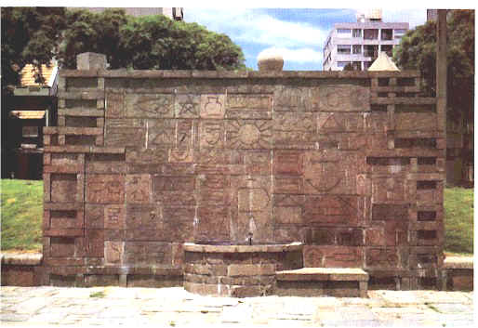

AAC, Monumento Cosmico 1937.
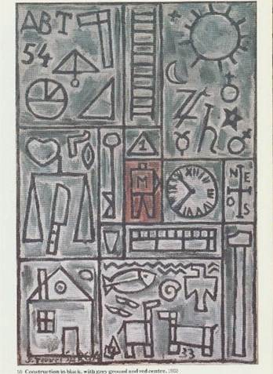

Joaquin Torres Garcia Construction in black with grey ground and red center. 1933.

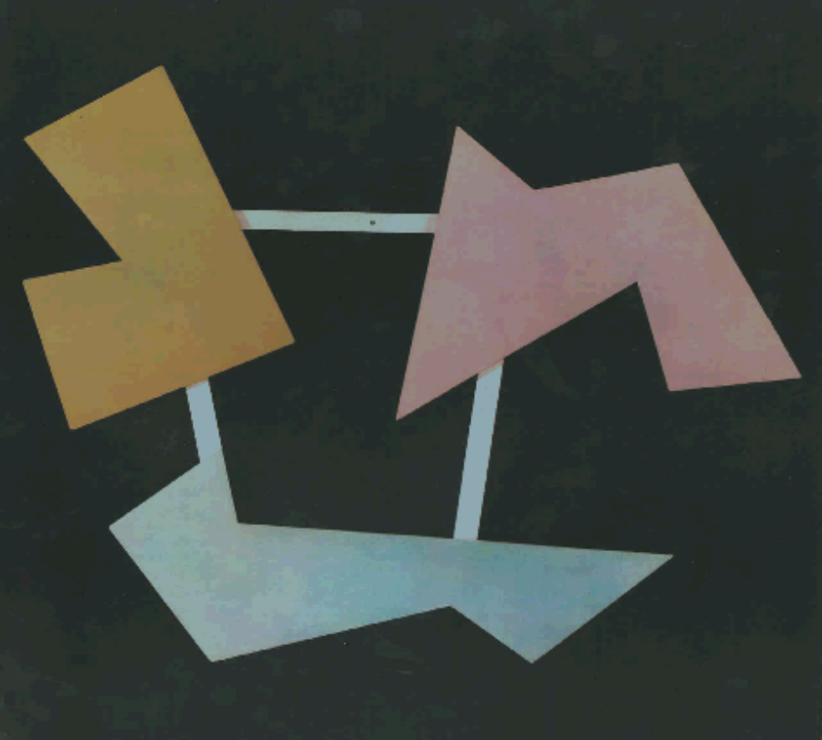

Raul Loza, Pintura 117
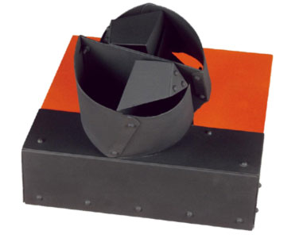

Edgar Negret, “Máscara” 1969.
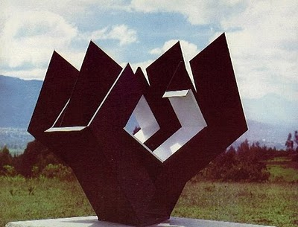

Edaurdo Ramirez Villamizar, Flor blanco y negro.

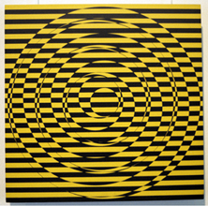
Mauricio Nogueira Lima, Objeto ritmico No 2 1953

